17.105: a) If all of the steam were to condense, the energy available to heat the water would be If all of the water were to be heated to 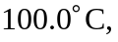the needed heat would be
Thus, the water heats to 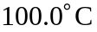 and some of the steam condenses; the temperature of the final state is 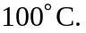
b) Because the steam has more energy to give up than it takes to raise the water temperature, we can assume that some of the steam is converted to water:
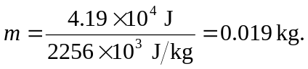
Thus in the final state, there are 0.219 kg of water and 0.021 kg of steam.

